HA - Stimulation of FTP Protocol (Design Based)

Authors :

|  |  |  |
| --- | --- | --- |
| Name | Roll No | Gr no |
| Abhijit Gawai | 18 | 11810895 |
| Bhargav Pawar | 46 | 118111248 |
| Nishant Bhat | 41 | 11810817 |
| Himanshu Pandey | 20 | 11810912 |
| Shyam Kawale | 27 | 11810933 |

AIM :

1. To send a file from PC2 to server0.

2. To get file from server0 to PC0.

3. To get file from server0 to PC2.

Connection :

Here we have 3PCs and one Server.

Server0 and PC2 are on network 192.168.10.0

PC0 and PC1 are on network 171.16.0.0

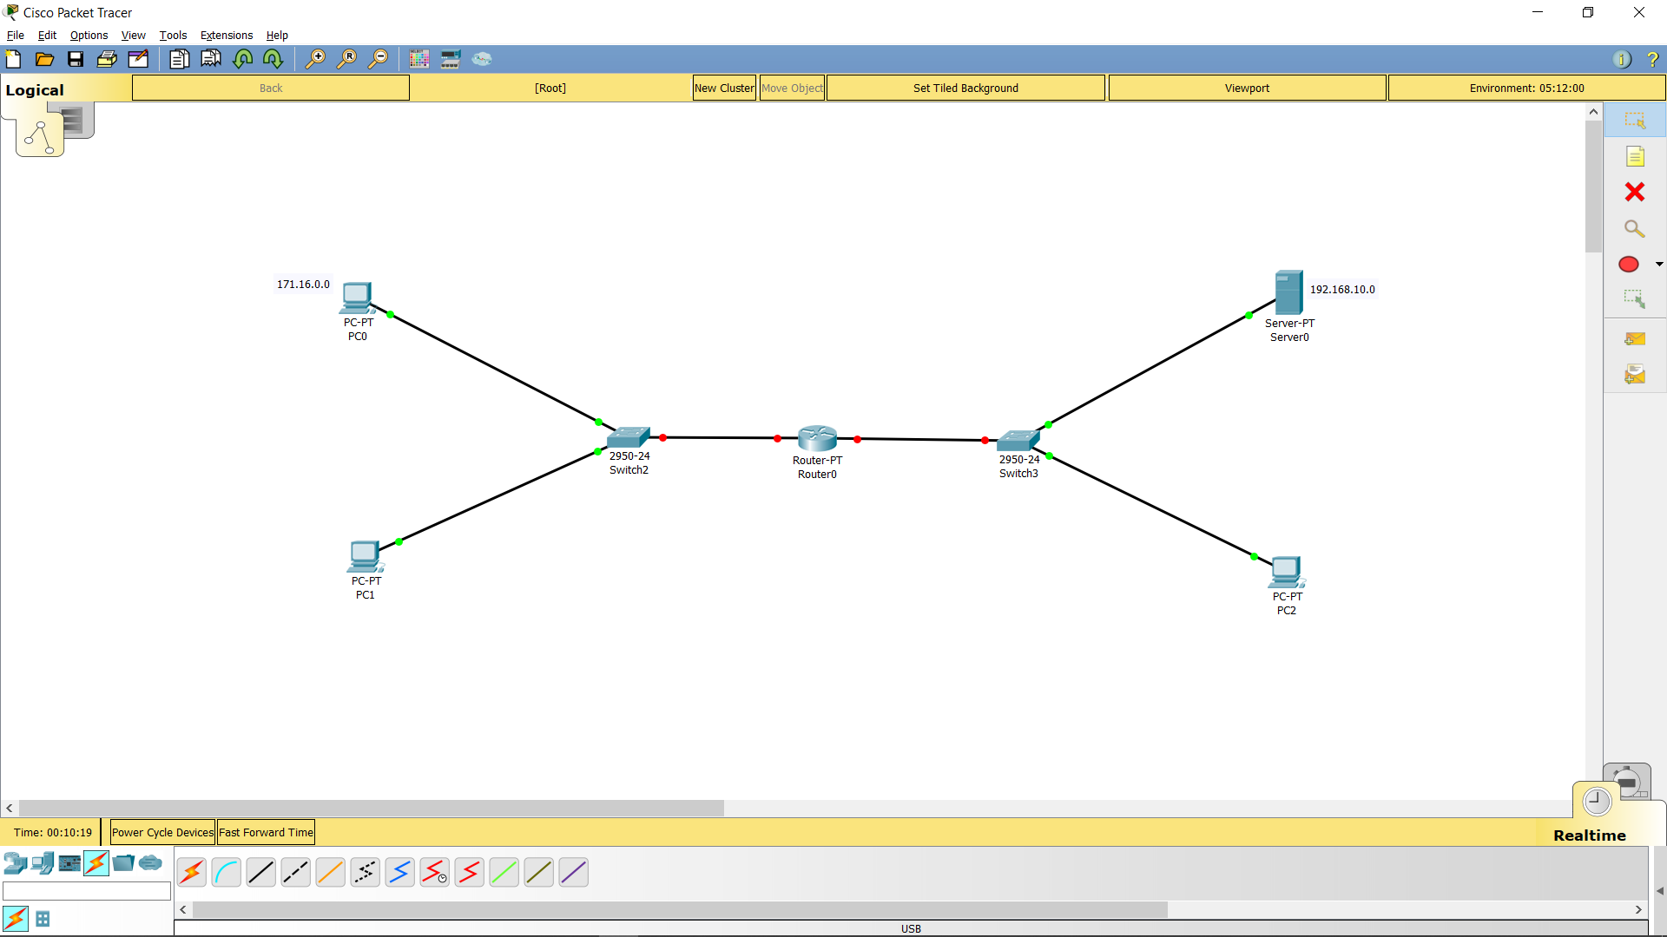

IP Configuration :

We configured IP of PC0,PC1,PC2, Server0 and Router0 to establish connection between two networks.

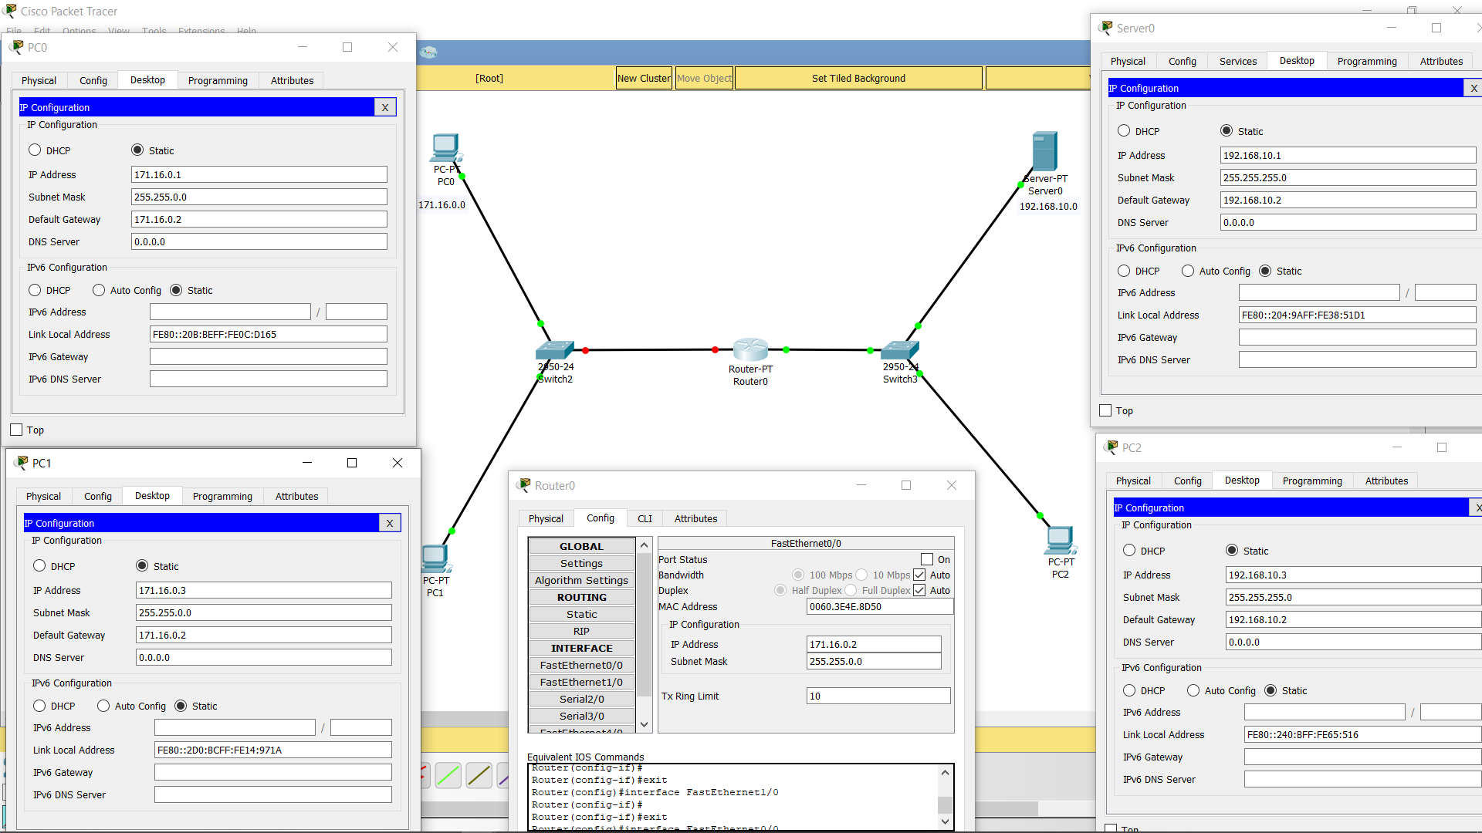

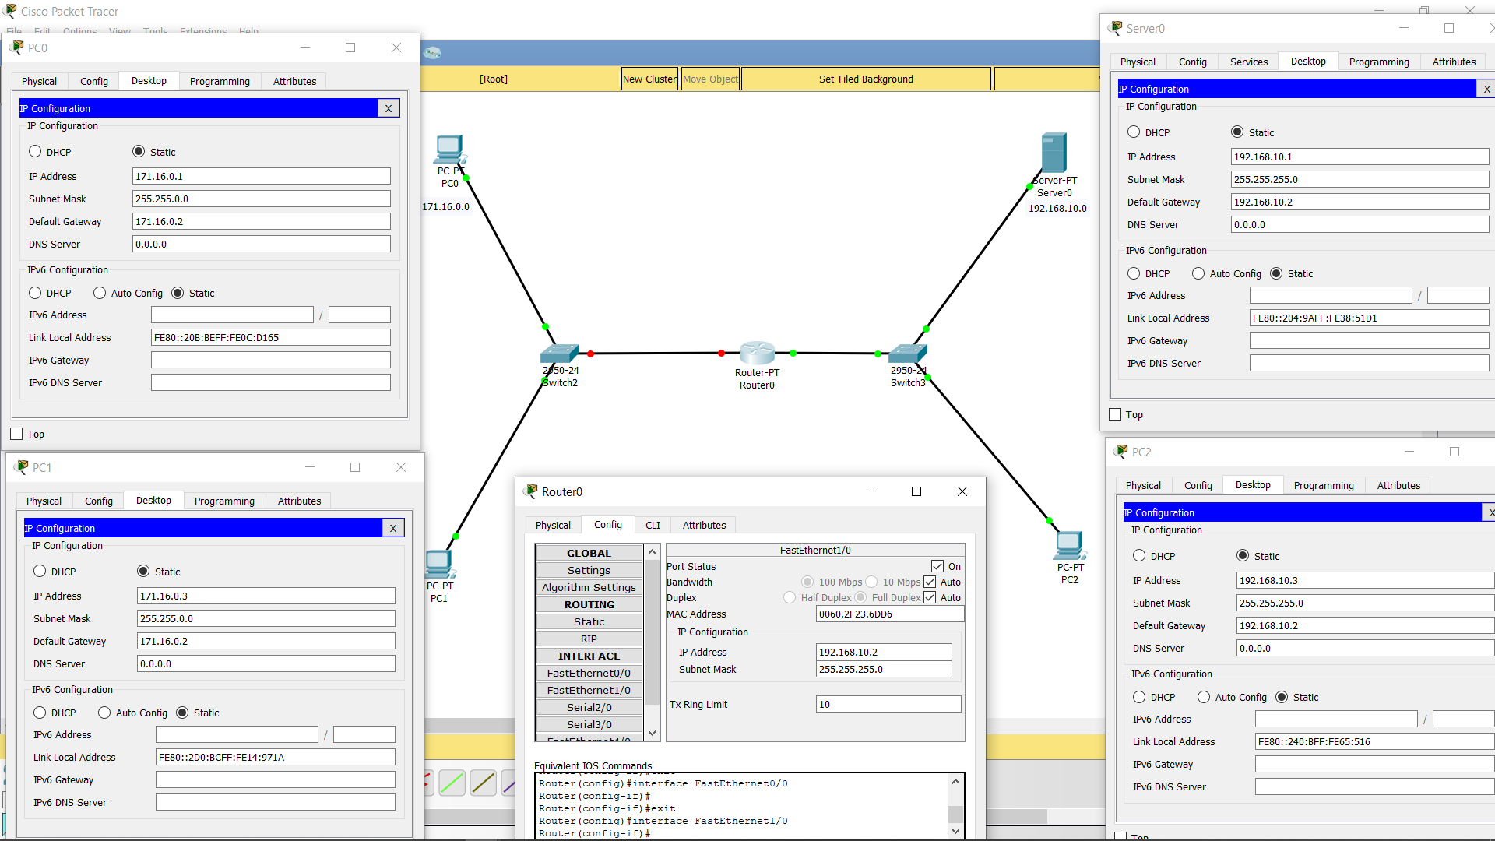

We created a FTP server by name=”abhi” and password=”gawai” on Server0

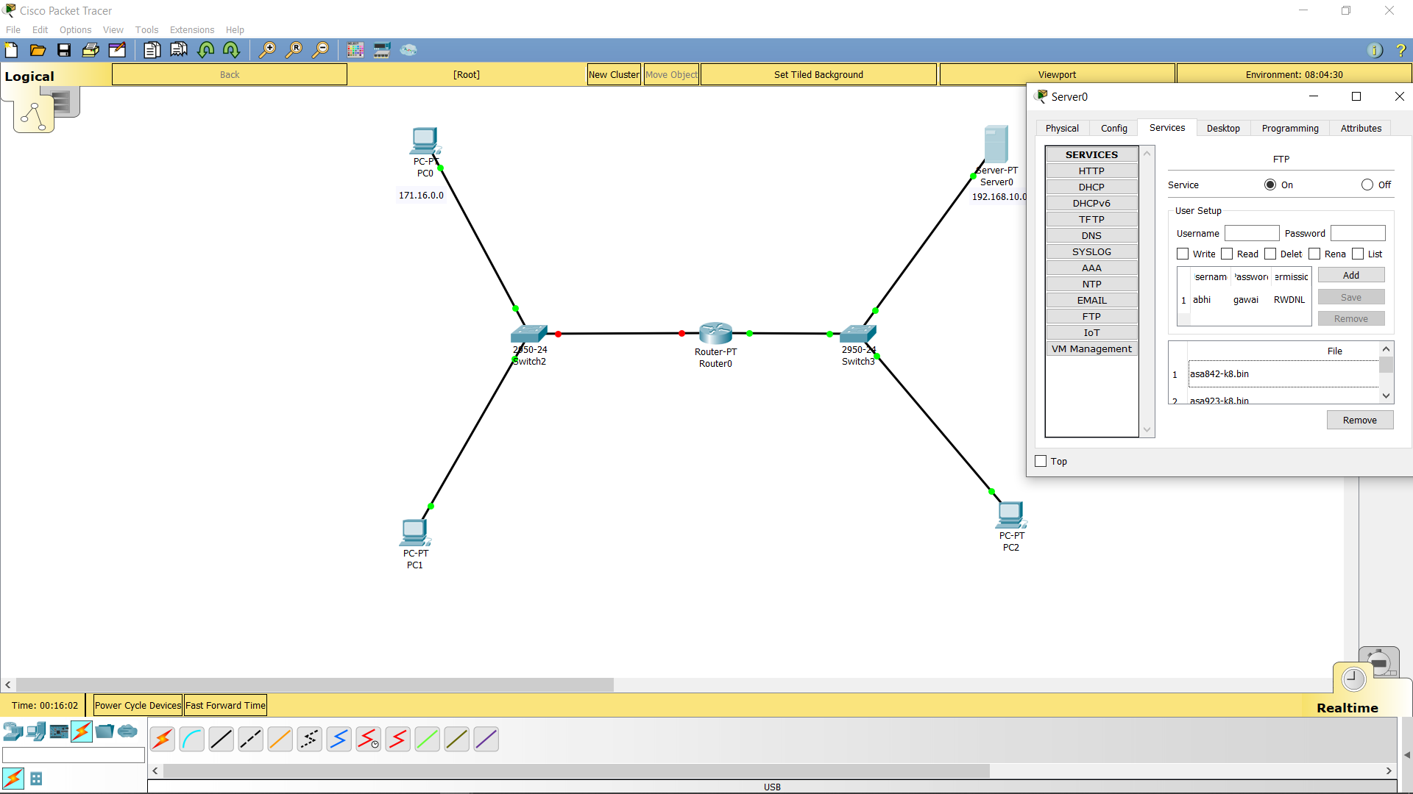

AIM1: To send a file from PC2 to server.

Creating File :

We created a file “abhi.txt” on PC2

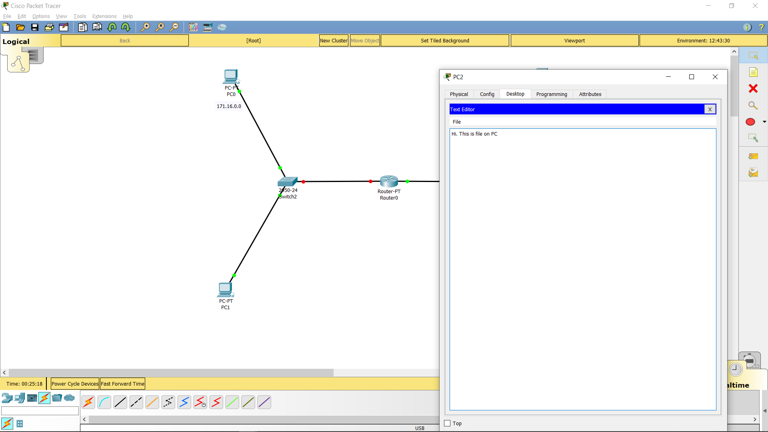

Sending File from PC2 to Server0 :

<this command are executed on PC2>

We connected to Server0 by “ftp 192.10.1“ and logged in

We sent file on Server0 by “put abhi.txt”

We conformed file on Server0 by “dir”

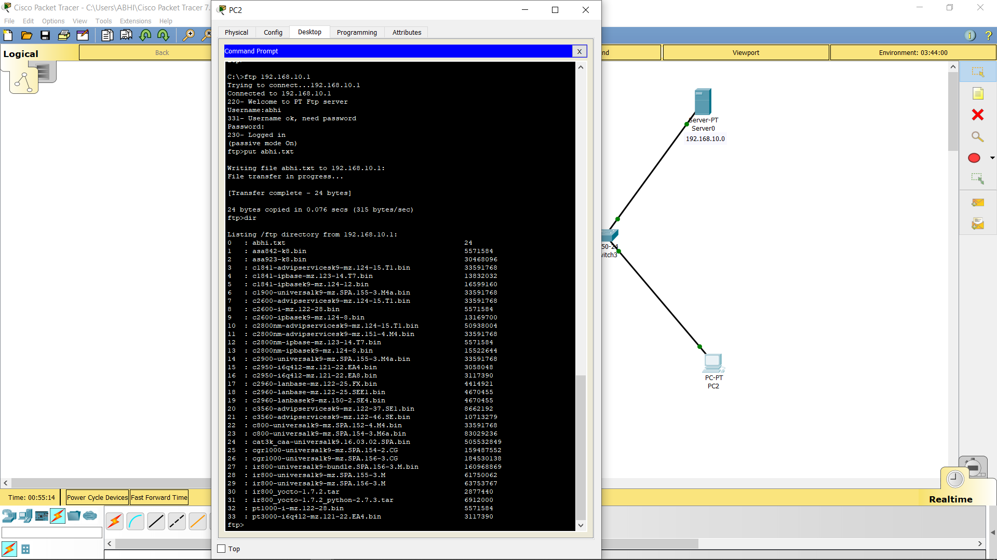

AIM2 : To get file from server0 to PC0

Reciving file form Server0 to PC0

<this command are executed on PC0>

We connected to Server0 by “ftp 192.10.1“ and logged in

We recive file on Server0 by “get abhi.txt”

We disconnected by Ctrl+C

We conformed file on PC0 by “dir”

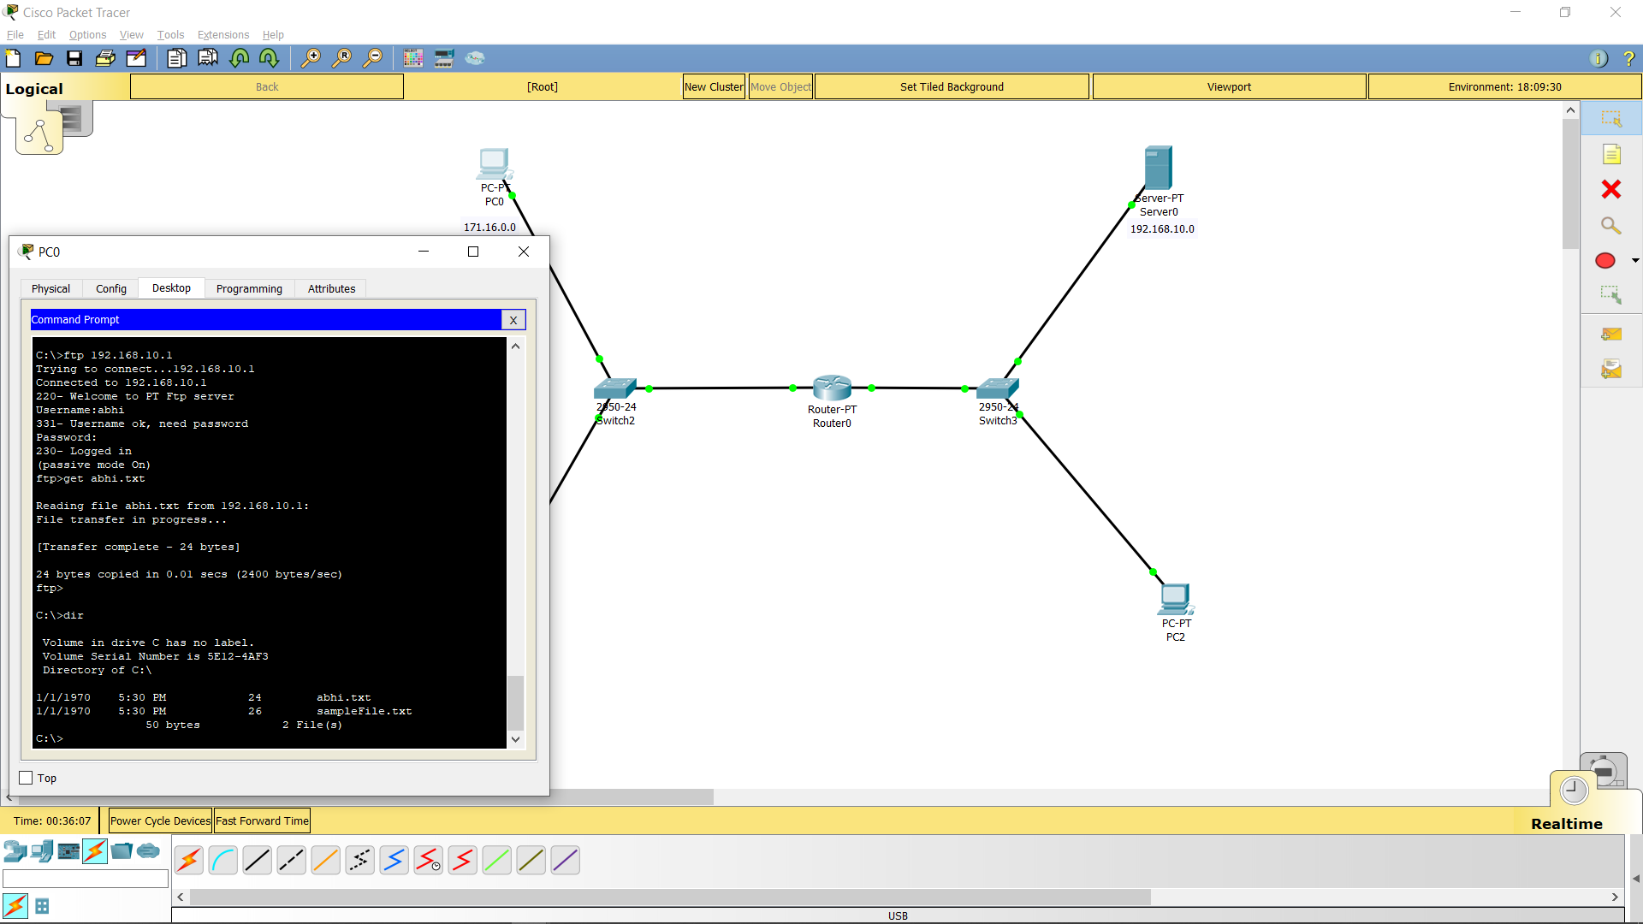

AIM3: To get file from server0 to PC1

Reciving file form Server0 to PC1

<this command are executed on PC1>

We connected to Server0 by “ftp 192.10.1“ and logged in

We recive file on Server0 by “get abhi.txt”

We disconnected by Ctrl+C

We conformed file on PC1 by “dir”

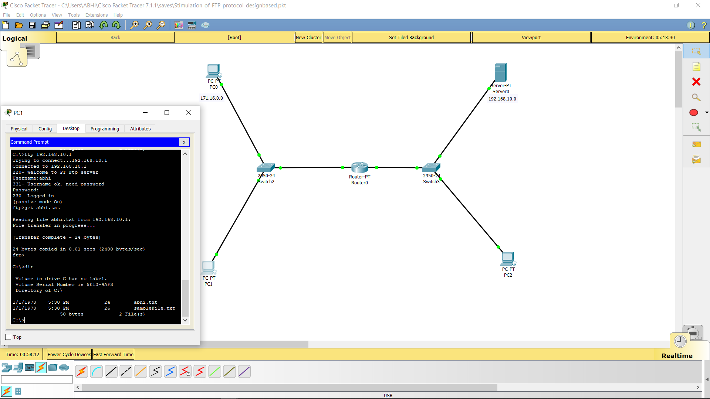

Plagiarism Report :

